Native is Chester Students’ Union’s event publishing and ticketing platform. All society-led events are to be submitted onto Native, whether tickets are free or paid. All society-led events require ticketing to ensure the safety of events.
Each society has been granted access to
- Create draft events
- Access event and sales reports
- Export/download ticket sales
- Use mobile scanning app / box office

Step 1: In your society inbox there will be an email from native inviting you to activate your account and create a new password.

Step 2:
Click create event in the top right-hand corner of the native dashboard. Complete the event details. If you need any support with completing this section, email b.bholah@chester.ac.uk

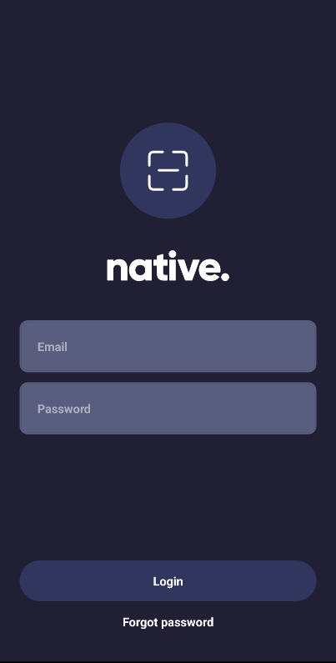
Step 3:
Designate 2 committee members to manage the box office/ticketing on the event day. To manage the ticketing, they will need to download the mobile app ‘Native Ticket Scanner’. They will be able to use the scanner on the app to check tickets.

